

British Values

Manuden Primary School
October 2023

Promoting British Values at Manuden Primary School

Preparing our children for life in modern Britain …

This booklet highlights how at Manuden primary School we promote the fundamental British values of democracy, the rule of law, individual liberty, mutual respect and tolerance of those with different faiths and beliefs in meaningful and understandable ways for the children at our school.

As well as actively promoting British values, we would actively challenge pupils, staff or parents expressing opinions contrary to fundamental British values, including ‘extremist’ views.



Democracy
We believe that the ability to communicate is an important area of learning and a key life skill. Democracy plays a key role at Manuden. Pupils can share their ideas through regular House Meetings and the various ambassador roles that we have at our school. We have ambassadors for the House Captains, Eco Squad, Safety, Sports and Anti-Bullying Ambassadors.

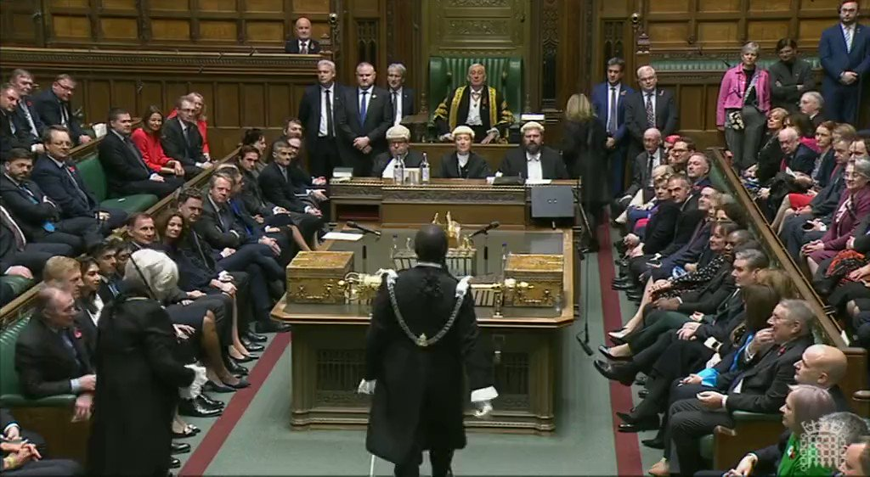
Elections are held for these roles and children are involved in each stage of the voting process. Throughout the year, the groups are involved in making important decisions within the school community.

Our child-friendly versions of our Safeguarding and Anti-Bullying policies are examples of how pupil voice is valued and promoted at our school.
Children are always encouraged to take an active role in class discussions and debates.

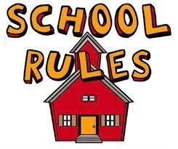
The Rule of Law

We endeavour to promote the optimum learning conditions for learning to take place. We believe it is key for children to understand right from wrong. The importance of Laws, whether they be those that govern the class, the school, or the country, are consistently reinforced throughout everyday school life.

Pupils are taught the reasons behind laws, that they govern and protect us, the responsibilities that this involves and the consequences when laws are broken.

Visits from authorities such as the Police and the Fire Service are regular parts of our school calendar and help reinforce this message.

Our simple three Behaviour rules (Is it safe, is it respectful, are you read) help us to work together to create a safe, calm, respectful and happy learning environment.

Through the PE curriculum in particular, children are taught acceptable behaviour and conduct and learn the value and importance of teamwork.

If a rule is broken, children are asked to reflect on what has happened through our Five W’s approach. Children are encouraged to identify and discuss which rule has been broken and are supported in understanding who has been affected and what they can do differently next time.

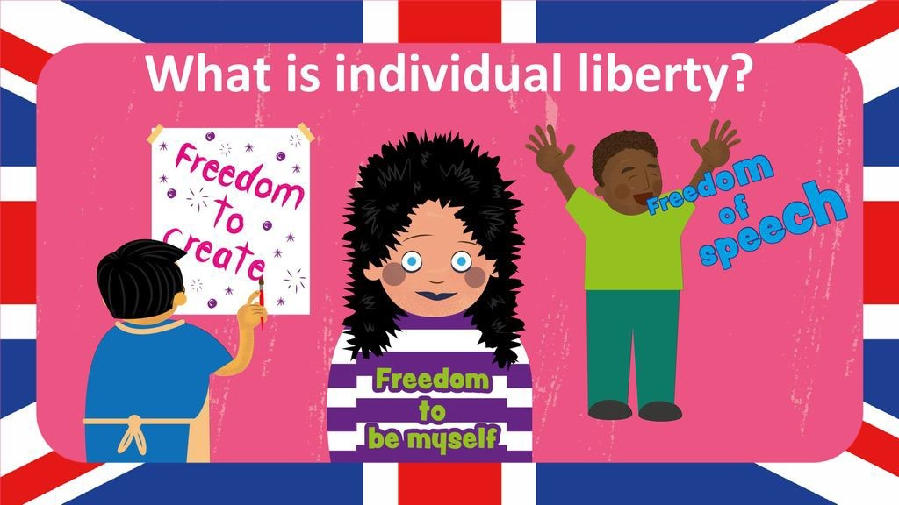
Individual Liberty

Making choices is an important element at Manuden. We create an environment that is safe and supportive. It is hoped that this environment provides children with the confidence to make their own choices.

All children are encouraged to become good and valued citizens. This is achieved by guiding each child to become as independent as possible. Through different aspects of school life and curriculum activities, children are encouraged to know, understand and exercise their rights and personal freedoms.

They learn and are supported in understanding how to exercise these appropriately and safely, for example through our eSafety and PSHE lessons. Whether it be through choice of challenge, of how they record, of participation in extracurricular clubs and opportunities, pupils are given the freedom to make choices.

Children’s independent learning skills are particularly enhanced through the range of child-led learning which takes place across the school. The school’s ‘Challenge Time’ sessions enable children to have complete ownership over their learning.

Our ‘Achieving through challenge’ school value supports children in having the skills and confidence to make their own choices.

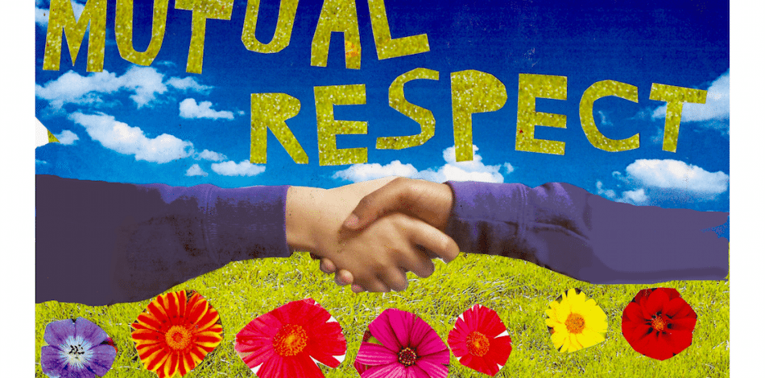
Mutual Respect

Mutual respect is core to everyday life at Manuden and all members of the school community are expected to treat each other with respect.

One of our three behaviour rules is ‘is it respectful’. We believe that for children to live out our school vision: ‘Nurturing life skills and inspiring achievement for today and tomorrow’, it is key for them to be able to live and work alongside people from all backgrounds and cultures.

Displays around our school promote respect for others and this is reiterated through our whole behaviour rules as well as in our behaviour policy. Respect is especially promoted through our ‘Celebration of British Events’ days when children are supported in learning and understanding about famous British figures and cultures.

Children are given opportunities to go into the community to meet with a range of people in a variety of contexts which include: sports events, community events and shared participation with other schools.

Tolerance of those of different faiths and beliefs


We aim to equip children with the ability to understand their place in a culturally diverse society and to provide them with rich opportunities to experience such diversity within our community. ‘Understanding and valuing others’ is one of our school values and is used to help children to respect faiths and beliefs that are different to their own.

Cultural appreciation and development are interwoven into our curriculum. Great emphasis is placed on providing encounters and participation in events and celebrations that enrich children’s experiences and awareness of others. We use opportunities such as the Olympics and the World Cup to study and learn about life and culture in countries such as Brazil.

Manuden is situated in an area which is not greatly culturally diverse, therefore we place a great emphasis on promoting diversity with the children. Assemblies are regularly planned to address this issue either directly or through the inclusion of stories and celebrations from a variety of faiths and cultures. Members of different faiths or religions are encouraged to share their knowledge to enhance leaning within classes and the school. Children visit places of worship that are important to different faiths.

